Faculty of computing
Department of Information Technology

Project Proposal

For Software Requirements Specification (SRS)

Submitted By
ALI MURTAZA
S23BINFT1M01001
Advanced eCommerce Management System with Integrated Logistics & Marketing
Session SPRING 2023 – 2027

Supervisor
Prof. Dr. Suleman Shah

Software Requirements Specification (SRS)

Advanced eCommerce Management System with Integrated Logistics & Marketing

1. Introduction

1.1 Purpose
The purpose of this document is to provide a detailed Software Requirements Specification (SRS) for the Advanced eCommerce Management System with Integrated Logistics & Marketing. This document describes all functional and non-functional requirements, system behavior, user characteristics, and constraints.

1.2 Scope
The system is a beginner‑friendly SaaS eCommerce platform that eliminates technical barriers. It includes:

- One‑click store builder (no coding required)
- One‑click product import from any external website
- AI‑based customer risk scoring
- Unified courier integration with AI‑powered delivery recommendations
- Integrated ad management (Meta Ads, TikTok Ads)
- Centralized dashboard for products, orders, shipping, and marketing

1.3 Definitions and Acronyms

Term | Definition
SRS | Software Requirements Specification
AI | Artificial Intelligence
ML | Machine Learning
SaaS | Software as a Service
API | Application Programming Interface
ROAS | Return on Ad Spend
PCI‑DSS | Payment Card Industry Data Security Standard
OAuth2 | Open Authorization 2.0

1.4 References
- Project Proposal by Ali Murtaza (March 25, 2026)
- Shopify API Documentation
- Meta Ads API Documentation
- TikTok Ads API Documentation
- Stripe & PayPal API Documentation

2. Overall Description

2.1 Product Perspective
The system is a self‑contained, web‑based platform that integrates with:

Integration Type | Examples
External eCommerce sites | Product import from any URL
Courier APIs | Local couriers, FedEx, DHL
Payment Gateways | Stripe, PayPal, local gateways
Advertising APIs | Meta Ads, TikTok Ads

2.2 User Characteristics

User Type | Description | Technical Skill
New eCommerce Entrepreneur | No coding or design experience | Low
Small Business Owner | Wants affordable, all‑in‑one solution | Low to Medium
Platform Administrator | Manages users, themes, platform settings | High

2.3 Sequence Diagram
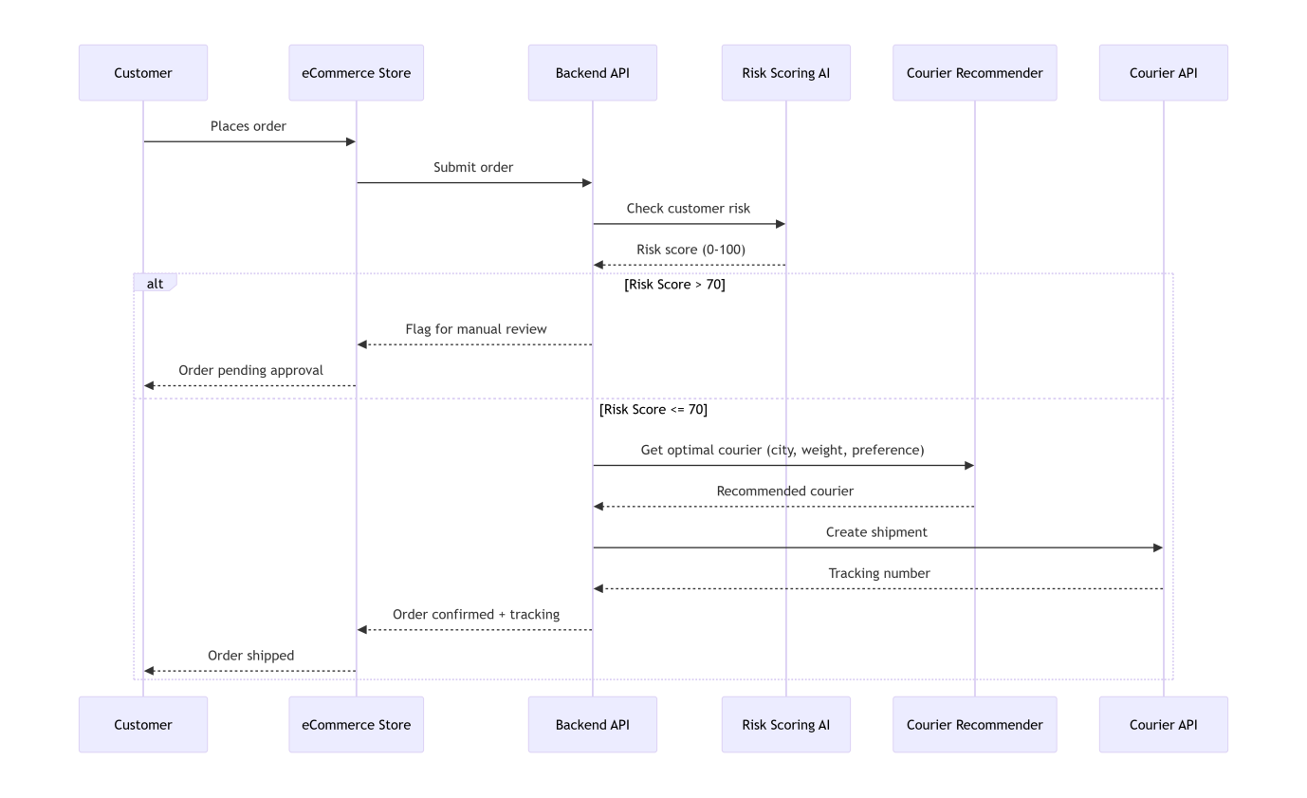

2.4 Operating Environment

Component | Environment
Client (Frontend) | Modern web browser (Chrome, Firefox, Safari, Edge) – responsive on mobile/tablet/desktop
Server (Backend) | Cloud (AWS/GCP), Linux, Node.js or Python (Django)
Database | PostgreSQL + Redis
AI Engine | Python microservices (scikit‑learn / TensorFlow)

2.5 Design and Implementation Constraints
- Stores must be accessible via subdomain: storename.platform.com
- Custom domain mapping must be supported
- PCI‑DSS compliance for payment processing
- OAuth2 for API authentication
- All themes must be fully responsive

2.6 Assumptions and Dependencies

Type | Description
Assumptions | Users have stable internet connection; third‑party APIs remain available
Dependencies | Courier, payment, and ad platforms must maintain their APIs; payment gateway accounts are managed by end‑users or platform operator

3. System Features and Requirements

3.1 Store Builder

ID | Requirement | Priority
SB‑01 | Provide at least 20 pre‑designed, responsive, customizable themes | High
SB‑02 | Include a visual editor to change colors, fonts, layouts, and content with real‑time preview | High
SB‑03 | One‑click publish to a subdomain (storename.platform.com) | High
SB‑04 | Support mapping of a custom domain (e.g., www.mystore.com) | Medium
SB‑05 | Allow drag‑and‑drop reordering of theme sections without coding | Medium

3.2 One‑Click Product Import

ID | Requirement | Priority
PI‑01 | User pastes a product URL from any external eCommerce site | High
PI‑02 | System automatically extracts title, images, price, description, and variants | High
PI‑03 | User reviews extracted data and adds to catalog with one click | High
PI‑04 | Support bulk import from collection/index pages | Low

3.3 Customer Risk Tracking (AI)

ID | Requirement | Priority
CR‑01 | Monitor each customer’s order history: cancellations, returns, fake orders, payment failures | High
CR‑02 | Assign a numeric risk score (0 = low risk, 100 = high risk) based on behavior | High
CR‑03 | Automatically flag customers with risk score above threshold (e.g., >70) | High
CR‑04 | Allow seller to accept, restrict, or block future orders from flagged customers | Medium

3.4 Unified Courier Integration

ID | Requirement | Priority
UCI‑01 | Single registration form to connect multiple courier APIs (local + FedEx, DHL) | High
UCI‑02 | Compare rates, print shipping labels, and track shipments without leaving platform | High
UCI‑03 | Automatically pull real‑time delivery status updates | High

3.5 AI‑Powered Courier Recommendation

ID | Requirement | Priority
AIC‑01 | Analyze historical delivery performance per city (success rate, transit time, cost) | High
AIC‑02 | For each new order, suggest optimal courier based on destination and user preference (speed vs. cost) | High
AIC‑03 | Provide dashboard showing courier performance metrics per city | Medium

3.6 Fast Payment Processing

ID | Requirement | Priority
PY‑01 | Integrate Stripe, PayPal, and at least two local payment gateways | High
PY‑02 | Support multiple currencies | Medium
PY‑03 | Include automated reconciliation of payments against orders | Medium

3.7 AI‑Based Delivery Optimization

ID | Requirement | Priority
DO‑01 | Use machine learning to predict delivery times based on courier, destination, day of week | High
DO‑02 | Recommend best dispatch time and carrier for each order to reduce delays | High
DO‑03 | Continuously retrain model with new delivery data | Medium

3.8 Marketing Integration

ID | Requirement | Priority
MK‑01 | Connect to Meta Ads and TikTok Ads via official APIs | High
MK‑02 | Display campaign metrics (impressions, clicks, cost per result, ROAS) in dashboard | High
MK‑03 | Allow users to pause/resume ads and adjust budgets from platform | High

3.9 ER Diagram

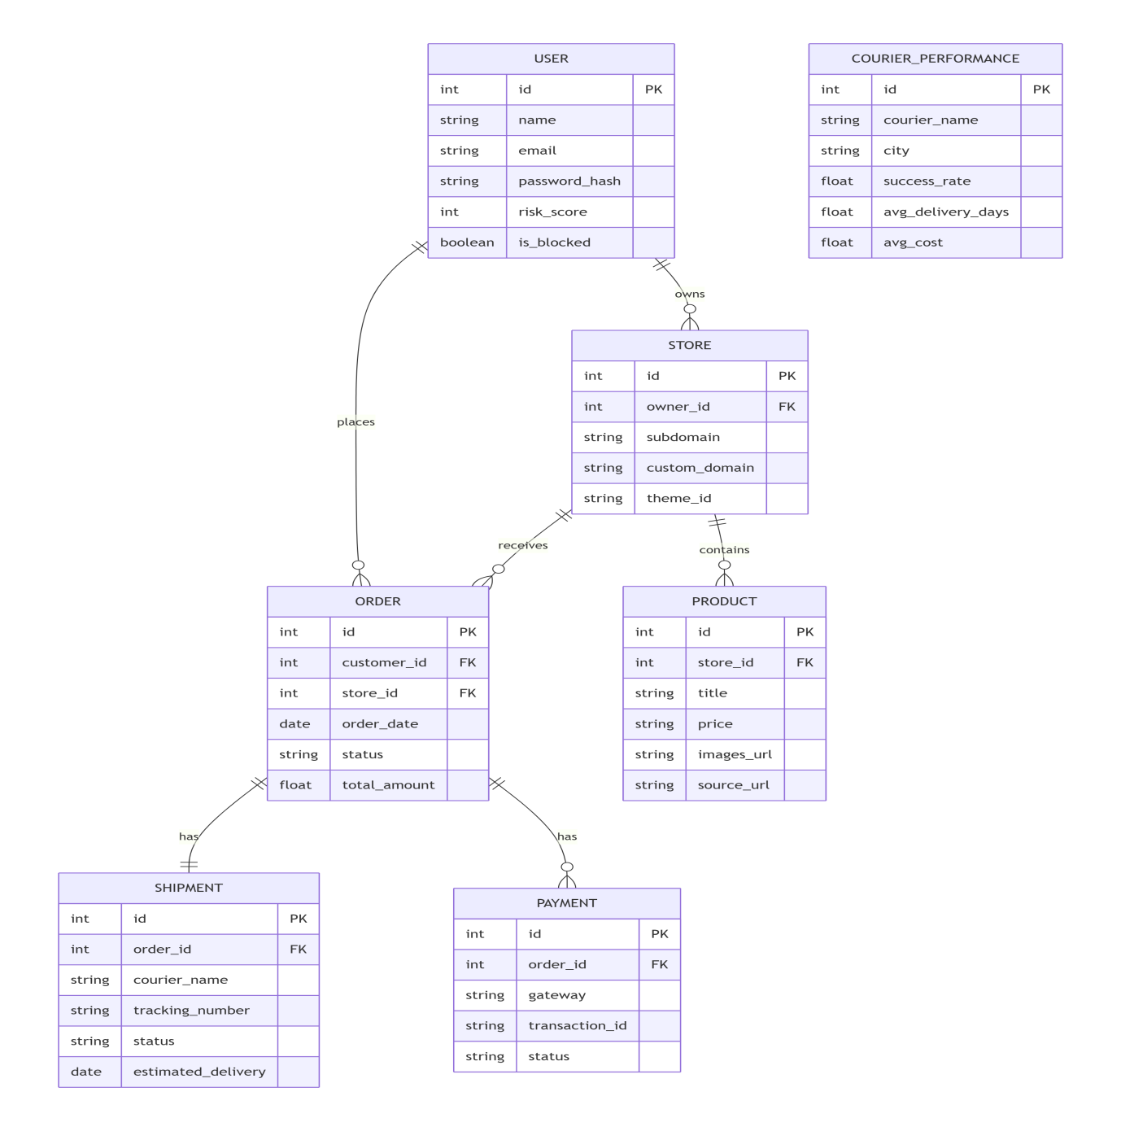

4. External Interface Requirements

4.1 User Interfaces
- Web‑based responsive UI using React.js with Tailwind CSS
- Visual theme editor (WYSIWYG)
- Mobile‑friendly dashboard

4.2 Hardware Interfaces
- None – system is entirely cloud‑based

4.3 Software Interfaces

Interface | Purpose | Protocol
Courier APIs (multiple) | Rates, labels, tracking | REST/JSON
Stripe / PayPal | Payment processing | REST/JSON
Meta Ads API | Campaign management | Graph API
TikTok Ads API | Campaign management | REST/JSON
Product Import Service | Scrape product data from external URLs | HTTP/HTML parsing + AI

4.4 Communication Interfaces
- HTTPS (TLS 1.2+)
- RESTful APIs for frontend‑backend communication
- Webhooks for real‑time order and payment updates

5. Non-Functional Requirements

5.1 Performance

ID | Requirement
NF‑P01 | Page load time < 3 seconds (under normal load)
NF‑P02 | System supports at least 100 concurrent store admins
NF‑P03 | AI risk scoring returns result within 2 seconds per customer

5.2 Reliability

ID | Requirement
NF‑R01 | 99.5% uptime (excluding scheduled maintenance)
NF‑R02 | Automated daily backups with 30‑day retention

5.3 Availability
- 24/7 availability
- Scheduled maintenance max 4 hours/month (announced 48 hours in advance)

5.4 Security

ID | Requirement
NF‑S01 | All data encrypted at rest (AES‑256) and in transit (TLS 1.2+)
NF‑S02 | OAuth2 authentication + optional 2FA
NF‑S03 | Role‑based access control (RBAC)

5.5 Usability

ID | Requirement
NF‑U01 | Beginner‑friendly onboarding (guided tour, tooltips)
NF‑U02 | Support for English and at least one local language (Urdu)
NF‑U03 | In‑app search and help documentation

5.6 Scalability
- Horizontally scalable via Kubernetes
- Auto‑scaling based on CPU/memory usage and request volume

5.7 Maintainability
- Modular microservice architecture
- Comprehensive API documentation (Swagger/OpenAPI)
- Code coverage > 70% for critical modules

5.9 Class Diagram

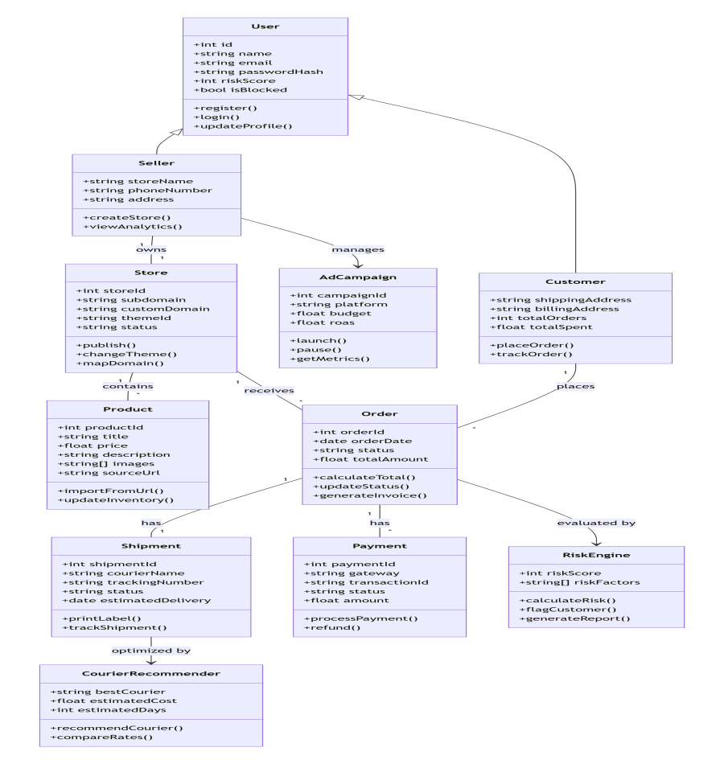

6. Security & Compliance

6.1 Data Security

Area | Requirement
Encryption | AES‑256 at rest, TLS 1.2+ in transit
Authentication | OAuth2, optional 2FA
Authorization | Role‑based (admin, editor, viewer)
Auditing | Logs for all critical actions (login, order changes, payment)

6.2 Compliance

Standard | Requirement
PCI‑DSS | Payment processing via integrated gateways (Stripe, PayPal) – platform not storing raw card data
GDPR (if applicable) | User data deletion, export, consent management
Local data laws | Data stored within country of operation (if required)

7. Future Scope

Feature | Description
Mobile App | iOS/Android app for store owners
Dropshipping Automation | Auto‑forward orders to suppliers
AI Chatbot | Customer support chatbot
WhatsApp Marketing Integration | Send order updates and promotions via WhatsApp
Multi‑language Storefront | Automatic translation of store content

8. Appendices

8.1 Glossary

Term | Definition
ROAS | Return on Ad Spend – revenue generated per unit of ad cost
WYSIWYG | What You See Is What You Get – visual editor
RBAC | Role‑Based Access Control

9 System Working Diagram

